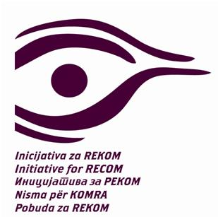

XII International Forum for Transitional Justice in Post-Yugoslav Countries

That Victims May Live on in Society’s Memory
Organised by the Coalition for RECOM
16 December 2019, Hotel Panorama, Zagreb, Croatia

9.00-9.15 Opening
Prof. Žarko Puhovski

9.15-11.00 Panel 1
Transitional Justice and Reconciliation in the Former Yugoslavia
Moderator: Tobias Flessenkemper, Head of the Belgrade Office of the Council of Europe

Pierre Mirel, Honorary Director General European Commision
Gordan Markotić, Coordinator of Croatia’s EU Presidency (tbc)
Nataša Kandić, project RECOM

10.00-11 Discussants
Thomas Unger, expert in the field of transitional justice
Mario Mažić, RECOM Coalition

11-11.30 Coffee and tea

11.30-14.00 Panel II
Politics and Practices of Memorialisation of the Events and Victims of the 1990s Wars
Moderator: Prof. Tvrtko Jakovina

Dr. Lea David, assistant professor, University College Dublin (UCD)
Protectors and Traders of the Past: The Case Study of Bosnia and Herzegovina
Prof. Dejan Jović, professor, Faculty of Political Sciences, University of Zagreb
Croatian Exceptionality: Official Narratives on Victors and Victims in the Croatian War of Independence
Dr. Jelena Đureinović, Humanitarian Law Centre
Official Commemorations of Operation Storm in Serbia
Dr. Ana Ljubojević, Marie Curie fellow, Centre for Southeast European Studies, University of Graz
Memory on Trial: The ICTY and Politics of Memory in Croatia and Serbia
Dr. Eli Kraniqi, university assistant, University of Graz
The Politics of Public Memory in post-1999 Kosovo

13.00 – 14.00 Discussion
Ivo Goldstein, historian
Commemorating Victims in Local Communities
Mirsad Duratović, Prijedor, BiH
Betim Berisha, Suva Reka, Kosovo

14-15.30 Lunch

15.30-17.00 Panel III
The ICTY Convicted: their lives After Serving Their Sentences?
Moderator: Marina Fratucan, journalist
Branka Vierda, YIHR Croatia
Marko Milosavljević, YIHR Serbia
Marigona Shabiu, YIHR Kosovo
16.15-17.00 Discussants
Verona Cecaj, LSE
Sven Milekić, Phd Maynooth University

17.00-17.30 Closing Statements

