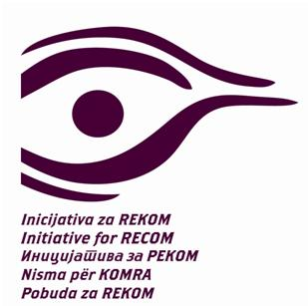
IX RECOM Coalition Assembly
12/15/2019 Zagreb, Croatia
13.30 - 14.00 registration
14.00 - 15.30 lunch
15.30 -16.15
Opening of the Assembly: Natasa Kandic and Vesna Terselic, initiators of the RECOM Initiative
Election of the Working Presidency of the Assembly of the Coalition for RECOM
Selection of the Verification and Election Commission, the recorder and the record verifier
Recording of the present members and members of the Assembly and determining the quorum
Report of the Verification and Election Commission
Adoption of the agenda of the Eighth Assembly of the Coalition for RECOM
16.15 – 16.30
Adoption of a transcript (minutes) from the Eighth Assembly of the RECOM Coalition
16.30 -17.30
Director-General for Neighbourhood and Enlargement Negotiations at the European Commission Christian Danielsson, Berlin Process Ministerial Meeting in Warsaw : “We stand ready to support actions that come from the region and for the region. We have asked an ex-Director General of the Commission Pierre Mirel to reach out to you to see how you can best build consensus on a way forward” – report by Pierre Mirel
RECOM Process Report: Nataša Kandić
Report on the project Strengthening the network for reconciliation: Tamara Milas, Center for Civic Education
17.30 -18.00
Pause (coffee and tea)
18.00 – 19.00
Restructuring of RECOM Initiative, Tasks and Objectives: Nataša Kandić
A word from public advocates: Žarko Puhovski, Židas Daskalovski, Adriatik Kelmendi I Dinko Gruhonjić
A word from delegates.
The decision on RECOM process priorities.
Election of a new member of the Regional Council
19.00
Closing words
Natasa Kandic and Vesna Terselic

